SMART WHEELCHAIR FOR PHYSICALLY CHALLENGED PEOPLE

Project Report

Submitted by:

Ashika. B
Harshitha J
Swathi S

Under the guidance of,
Dr. D. Veera Vanitha
DEPARTMENT OF ELECTRONICS AND COMMUNICATION ENGINEERING
SCHOOL OF ENGINEERING
AVINASHILINGAM INSTITUTE FOR HOME SCIENCE AND HIGHER EDUCATION FOR WOMEN
COIMBATORE - 641043

TABLE OF CONTENT

CHAPTER TITLE NO.

ABSTRACT
- INTRODUCTION
- LITERATURE SURVEY
- METHODOLOGY
  - Proposed method
  - Block diagram
  - Hardware description
3.3.1.NodeMCU ESP 8266
    - GPS Module (NEO-6M)
3.3.3Ultrasonic Sensor (HC-SR04)
3.3.4 Motor Driver (L293D) 3.3.5 BO Motors
  - Flow chart
3.4.1 Alogrithm
- RESULT AND DISCUSSION
- CONCLUSION
REFERENCS

ABSTRACT

The smart wheelchair navigation system is a transformative solution designed to enhance mobility and independence for individuals with disabilities. By integrating advanced features such as automatic movement, obstacle detection, GPS tracking and mobile app control, it ensures both convenience and safety. Its modular design allows for easy attachment to existing wheelchairs, providing an affordable alternative to fully automated models. While the system demonstrates effective performance in obstacle avoidance and remote monitoring, areas such as detection accuracy, battery efficiency, and connectivity require further refinement for improved reliability. This innovative system represents a significant leap in assistive technology, offering a scalable and practical solution for improved mobility while addressing the diverse needs of its users.

CHAPTER 1
INTRODUCTION

The smart wheelchair navigation system aims to revolutionize mobility for individuals with physical disabilities. Traditional wheelchairs often lack the advanced features needed to navigate complex environments independently. This project addresses these limitations by integrating cutting-edge technologies to provide autonomous navigation, obstacle avoidance, and real-time location tracking. The system combines sensors, microcontrollers, and actuators to create a wheelchair capable of intelligently navigating both indoor and outdoor settings. The ultimate goal is to provide a safer, more efficient, and user-friendly mobility solution, significantly enhancing the quality of life for users with mobility impairments.

Building upon existing methods such as sensor-based navigation, voice and gesture control, and IoT connectivity, this project introduces a unified system design that integrates these features into a central control unit with a modular and scalable architecture. The system uses real-time processing of sensor data for obstacle detection, terrain adaptation, and personalized navigation. Safety measures include emergency stops, collision avoidance, and IoT connectivity for remote monitoring. Smart battery systems and multi-modal interfaces ensure efficient and user-friendly operation.

The core of the system includes components such as the NodeMCU ESP8266 microcontroller for central control, a Neo-6M GPS module for location tracking, L293D motor driver shields with DC motors for precise movement, and ultrasonic sensors for obstacle detection. These components work together to enable autonomous wheelchair navigation, providing users with increased independence and enhanced mobility. The integration of these technologies represents a significant advancement in assistive mobility devices, promising a transformative impact on the lives of individuals with disabilities.

CHAPTER 2
LITERATURE SURVEY

Smart Wheelchair Systems with Pressure Ulcer Prevention

Ramanan et al. (2024) designed and developed a smart wheelchair system using Raspberry Pi, incorporating a hydrogel-based cushion and pressure mapping system to prevent decubitus ulcers. The system also includes obstacle detection to enhance mobility. This study addresses the critical issue of pressure ulcers in wheelchair users by integrating innovative materials and sensors, improving comfort and preventing secondary health complications.

Voice Controlled Wheelchairs

Venkatakrishnan et al. (2024) introduced a voice-controlled wheelchair designed to enhance therapeutic care and reduce labor. The wheelchair features an adjustable backrest and leg rest, obstacle collision prevention, and a voice recognition module, making it suitable for users with physical disabilities. This research highlights the potential of voice control to improve the usability and functionality of wheelchairs, providing a more intuitive interface for users with limited mobility.
IoT-Based Smart Wheelchairs
Kumar et al. (2024) explored the application of IoT in smart wheelchairs to enhance mobility, independence, and safety for disabled individuals. The proposed system integrates advanced technologies such as obstacle avoidance, voice control, and self-navigation. This study emphasizes the role of IoT in creating interconnected and intelligent assistive devices that can significantly improve the quality of life for people with disabilities by providing real-time data and remote monitoring capabilities.

Vision-Based Autonomous Wheelchairs

Masud et al. (2024) presented a vision-based autonomous wheelchair controlled through eye movements, designed to improve mobility and independence for fully handicapped individuals. The system incorporates obstacle detection to ensure safe navigation. This research demonstrates the potential of vision-based control systems to provide hands-free operation, offering a valuable alternative for individuals who cannot use traditional manual controls.

AI-Powered Automated Wheelchairs

Abiraj et al. (2024) proposed an AI-powered automated wheelchair with lane detection and multiple recognition methods, including voice, gesture, facial, and gaze recognition. The system also includes health tracking and communication features. This study showcases the advantages of AI in creating versatile and user-friendly wheelchairs that can adapt to different user needs and environmental conditions, improving overall mobility and health management.
Smart Wheelchair Control Systems

Ding et al. (2024) introduced a smart wheelchair control system based on a Hall rocker and incremental PID algorithm for precise, safe, and optimized driving performance. The proposed system aims to enhance the control and stability of the wheelchair, ensuring a smoother and more reliable user experience. This research highlights the importance of advanced control algorithms in achieving precise and efficient wheelchair operation.

CHAPTER 3
METHODOLOGY

3.1 PROPOSED METHOD

Our proposed methodology integrates a multi-sensor system with modular hardware and software components to transform standard wheelchairs into intelligent, app-controlled devices. Ultrasonic sensors detect obstacles, employing avoidance strategies and real-time distance calculations . A microcontroller processes sensor data alongside GPS module inputs for location tracking, while autonomous navigation The system connects to a mobile app through Bluetooth/Wi-Fi, enabling dual control modes: autonomous obstacle avoidance and manual steering via Mobile Application with real-time GPS positioning displayed on the app. Mechanical customization focuses on attachable kits and standardized mounting hardware, ensuring compatibility of the wheelchairs. Power management optimizes battery consumption for continuous sensor operation and wireless connectivity, maintaining affordability while meeting safety standards through rigorous testing of obstacle detection accuracy and situation recognition.

3.2 BLOCK DIAGRAM

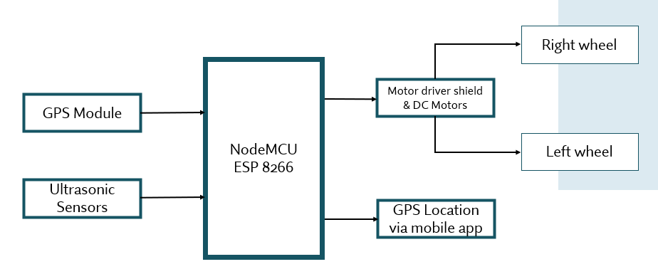
Fig 3.1 Shows the overall blocks of navigation system

HARDWARE DESCRIPTION

NodeMCU ESP8266
The NodeMCU ESP8266 is an open-source IoT platform featuring the ESP8266 WiFi SoC (System on Chip) from Espressif Systems. Key specifications include:
      - Processor: Tensilica L106 32-bit microcontroller
      - Operating Voltage: 3.3V
      - Digital I/O Pins: 11
      - Analog Input Pins: 1 (ADC)
      - Flash Memory: 4MB
      - Clock Speed: 80MHz
      - WiFi: IEEE 802.11 b/g/n
In our smart wheelchair system, the NodeMCU ESP8266 serves as the central processing unit, handling data from all sensors, executing navigation algorithms, and controlling motor operations. Its built-in WiFi capability also enables potential remote monitoring and control features, enhancing the system's functionality. The compact size and low power consumption make it ideal for mobile applications like our wheelchair system.

GPS Module (NEO-6M)
The NEO-6M GPS module is a high-performance Global Navigation Satellite System (GNSS) receiver that provides precise geographical positioning data. Key specifications include:
      - Operating Voltage: 3.3V to 5V
      - Position Accuracy: 2.5m
      - Velocity Accuracy: 0.1m/s
      - Hot Start Time: <1s
      - Cold Start Time: <27s
      - Maximum Update Rate: 5Hz
      - Communication Interface: Serial (UART)
      - Operating Temperature: -40°C to 85°C
In our system, the NEO-6M GPS module enables the wheelchair to determine its precise location in outdoor environments, essential for following predetermined routes and reaching specific destinations. The module provides real-time coordinate data (latitude and longitude) that the navigation algorithm uses to calculate movement directions. The compact form factor and low power consumption make it suitable for integration into our portable wheelchair system.

Ultrasonic Sensor (HC-SR04)
The HC-SR04 is an ultrasonic distance sensor that uses sonar to determine distance to an object. Key specifications include:
      - Operating Voltage: 5V
      - Operating Current: 15mA
      - Working Frequency: 40Hz
      - Range: 2cm to 400cm
      - Resolution: 0.3cm
      - Measuring Angle: 15 degrees
      - Trigger Input Signal: 10μs TTL pulse
      - Echo Output Signal: PWM
Our smart wheelchair system incorporates multiple HC-SR04 sensors strategically positioned to provide 360-degree obstacle detection. These sensors transmit ultrasonic waves that reflect off objects and return to the sensor, with the time difference between transmission and reception used to calculate distance. This continuous monitoring enables the wheelchair to detect obstacles in its path and execute appropriate avoidance maneuvers, ensuring the safety of the user during navigation.

Motor Driver (L298N)

The L298N is a dual full-bridge motor driver integrated circuit capable of controlling two DC motors simultaneously in both forward and reverse directions. Key specifications include:
      - Supply Voltage(Vss): 5V to 35V
      - Peak Output Current : 2A per channel
      - Maximum Power Dissipation: 25W
      - Number of Channels: 2(can drive 2DC motors)
      - Input Logic Voltage: 4.5V to 7V
      - Operating Temperature: -25°C to 130°C
      - Enable Pins for Motor Activation

In our wheelchair system, the L298N motor driver functions as the intermediary between the NodeMCU microcontroller and the BO motors. It amplifies the low-power control signals from the NodeMCU into sufficient current levels to operate the motors effectively. With PWM (Pulse Width Modulation) input, the L298N enables speed and direction control for both motors, facilitating all essential movement commands such as forward, reverse, left turn, right turn, and stop. The built-in heatsink also supports thermal dissipation, ensuring reliable operation under continuous load.

BO Motors
BO (Battery Operated) motors are DC geared motors commonly used in robotics and small electric vehicles. Key specifications include:
      - Operating Voltage: 3V to 12V
      - No-Load Speed (at 12V): 200 RPM
      - Stall Torque: 2 kg-cm
      - No-Load Current: 60mA
      - Stall Current: 300mA
      - Gear Ratio: 1:150
      - Shaft Diameter: 6mm
      - Weight: 100g
Our wheelchair system utilizes four BO motors, two for each rear wheel, providing adequate torque for smooth movement even with the weight of the user. These motors are selected for their reliability, torque characteristics, and speed control capabilities. The gear mechanism within the motors provides the necessary torque multiplication to move the wheelchair efficiently across various surfaces while maintaining precise control over speed and direction.

3.4 FLOW CHART
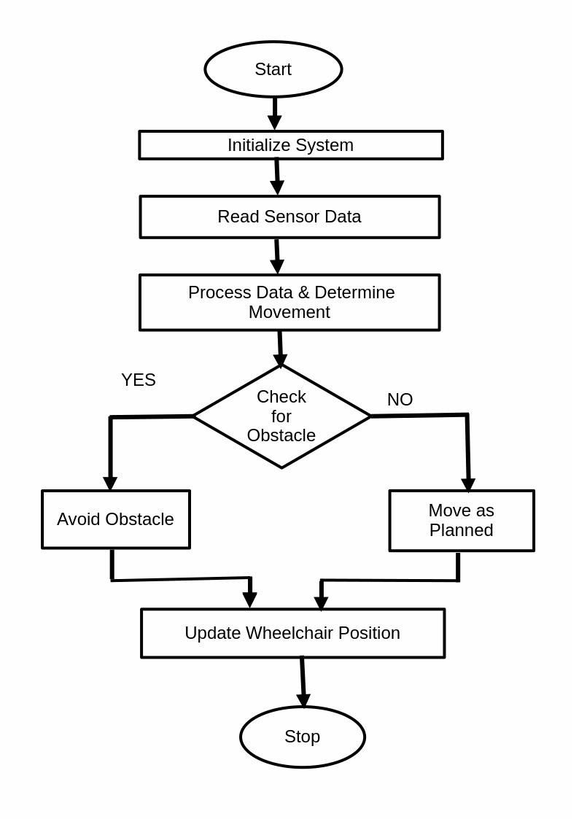

Fig 3.2 Process Flow

3.4.1 ALGORITHM

Step 1: Start the program

Step 2: Set up ESP8266, sensors (Ultrasonic, GPS), and motor driver.

Step 3: Collect real-time data from the Ultrasonic sensor and GPS module.

Step 4: Analyze sensor data to decide the wheelchair's next movement.

Step 5: Check for Obstacles use the ultrasonic sensor to detect obstacles in the path.

Step 6: If an ‘Obstacle is Detected’ execute obstacle avoidance maneuvers.

Step 7: If ‘No Obstacle is Detected’ Move the wheelchair as per the planned path.

Step 8: Update Wheelchair Position modify the wheelchair's position based on the executed movement.

Step 9: Either stop or repeat the process for continuous navigation.

CHAPTER 4

RESULT AND DISCUSSION

The developed smart wheelchair navigation system successfully combines automation, obstacle avoidance, mobile connectivity, and GPS tracking to enhance user mobility and safety. It features automatic navigation with ultrasonic sensors that detect and avoid obstacles, ensuring smooth and collision-free movement. A mobile app allows manual control and displays real-time GPS data, enabling caregivers to monitor the user’s location. The integrated GPS module provides accurate tracking, enhancing safety further. Designed to be modular and cost-effective, the system can be easily adapted to existing wheelchairs and customized to meet specific user requirements.

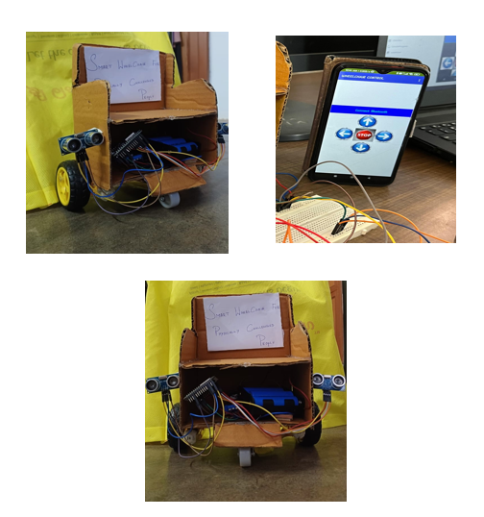

A prototype image IS attached for reference.

This system enhances mobility, independence, and safety for users. Automation and remote control via the app make it user-friendly, while GPS tracking ensures monitoring for caregivers. The modular design makes it a practical and low-cost solution compared to fully automated wheelchairs.

Challenges include improving obstacle detection, battery efficiency, and connectivity stability. Future upgrades may include replacing ultrasonic sensors with radar for higher obstacle detection accuracy.

CHAPTER 5

CONCLUSION

The smart wheelchair navigation system offers an efficient and cost-effective solution for enhancing mobility and independence for individuals with disabilities. By integrating automatic movement, obstacle detection, mobile app control, and GPS tracking, it provides both convenience and safety. The modular design allows easy attachment to existing wheelchairs, making it an affordable alternative to fully automated models.While the system performs well in obstacle avoidance and remote monitoring, improvements in detection accuracy, battery efficiency, and connectivity can further enhance its reliability. Future upgrades, such as radar-based obstacle detection and AI-driven navigation, will increase precision and user experience. Overall, this smart wheelchair system represents a significant step forward in assistive technology, offering a practical and scalable solution for enhanced mobility.

REFERENCES

1. Leaman, J., & La, H. M. (2017). "A Comprehensive Review of Smart Wheelchairs: Past, Present, and Future." IEEE Transactions on Human-Machine Systems, 47(4), 486-499.

2. Simpson, R. C. (2005). "Smart Wheelchairs: A Literature Review." Journal of Rehabilitation Research & Development, 42(4), 423-438.

3. Parikh, S., Grassi, V., Kumar, V., & Okamoto, J. (2007). "Integrating Ultrasonic and Infrared Sensors for Obstacle Avoidance in Wheelchair Navigation." Proceedings of the IEEE International Conference on Robotics and Automation (ICRA), 611-616.

4. Ali, A., & Ismail, M. (2019). "A GPS-Based Smart Wheelchair Navigation System for Disabled Individuals." International Journal of Engineering & Technology, 8(1), 55-61.

5. Mohamed, A., & Shamsudin, S. (2021). "Comparing Ultrasonic and Radar Sensors for Autonomous Wheelchair Navigation." Sensors & Actuators Journal, 5(3), 102-110.

